Refraction of Light – PhET Simulation Lab

*First of all, my things to Tristan O’Hanlon of the University of Aukland, author of “Lab 2 – Refraction of Light”, for posting his work in the teachers resources section of the PhET website! Much of this activity is pilfered with permission from this source.*

**Objectives:**

* Verify Snell’s Law and use it to identify an unknown material
* Determine how intensity changes when light refracts

**Background:**

Light travels at different speeds in different substances. Light travels faster in water than in diamond, it travels faster in air than in water, and it travels the fastest in a vacuum. One way of indicating how fast the speed of light is in a particular substance is to give that substance’s ***index of refraction***, denoted *n*. The index of refraction for a substance is defined as the ratio of the speed of light in a vacuum to the speed of light in that substance:

nsubstance = c/vsubstance

For example, the index of refraction for water is 1.33. This means that light travels 1.33 times faster in vacuum than water.

When light travels from one medium into another, the path of the light will bend if two things are true:

* The media have different indices of refraction
* The path of the light makes a non-zero angle with the normal to the boundary.

The following equation, called ***Snell’s Law***, shows the relationship between the angle of incidence, the angle of refraction, and the indices of refraction of the two substances involved.

Normal

n1 sin θ1 = n2 sin θ2

θ1

where n1 = Index of refraction

for initial medium

Medium #1

n2 = Index of refraction

for second medium

Medium #2

θ1 = Angle of incidence

θ2 = Angle of refraction

θ2

For this lab you will be using an online simulator from the University of Colorado Boulder. Click on the link below to get to the website:

<https://phet.colorado.edu/sims/html/bending-light/latest/bending-light_en.html>

Once you get there, click on ‘Intro’.

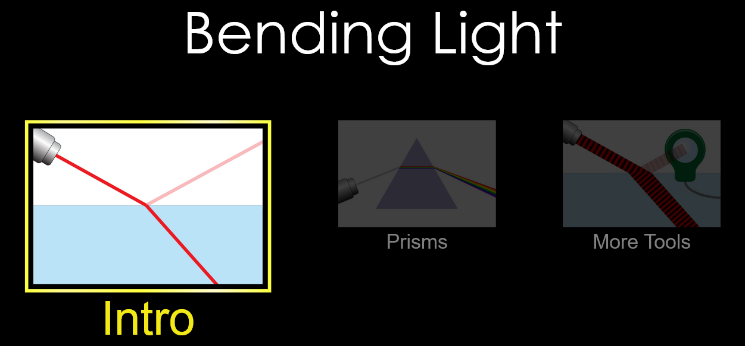

**Part 1: Confirming Snell’s Law**

1. When the simulator window opens, you should notice a laser pointing at a **45o angle downwards to the right**.Look to the right of the window and notice that the two information boxes are explaining the mediums that are shown on the screen.
2. Click on the **RED** button on the laser.
3. Change the material of the second medium (where the refracted ray is) to Glass using the menu box on the bottom right.

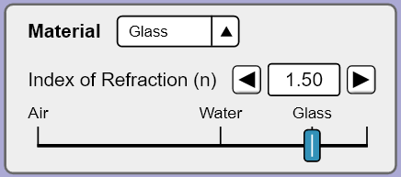

Choose the protractor tool and place the protractor over the vertical normal line **so that the dotted line runs straight through zero**. Set the laser (click on it and move it when the green arrows appear) to an angle of incidence , at 30°. Recall: angles are always measured from the Normal.

Ignore the reflected ray (the ray that remains in air). Using the protractor, measure the angle of refraction , of the laser and record this in Table 1.

Repeat these steps for 5 more angles of incidence of your own choosing. Record the results in Table 1.

|  |  |  |  |  |
| --- | --- | --- | --- | --- |
|  |  |  |  |  |
| 30 |  |  |  |  |
|  |  |  |  |  |
|  |  |  |  |  |
|  |  |  |  |  |
|  |  |  |  |  |
|  |  |  |  |  |

*Table 1*

1. Calculate sin*θ1* and sin*θ2* for each trial and add them to Table 1. Then, using your known value of *n1*, calculate a value for *n2* for each trial and add these values to Table 1. Keep your results to 2 or 3 significant figures.

**Analysis:**

1. Show a sample calculation demonstrating how you determined *n2* for one of your trials.
2. Were your values of the index of refraction for the new medium relatively consistent from trial to trial?
3. Calculate your average value of *n2*.
4. Calculate the percent error between your average value of *n2* and the accepted index of refraction of glass 1.50.
5. Even if your %-error is small, can you think of any reasons why you might have some error or uncertainty given your procedure for this activity?

**Part 2: Further Investigation of Light Intensity**

1. Reset the simulation to initial conditions.
2. On the bottom left side of the simulator window, you should notice that you have two tools available for you to use. Select the bottom tool that looks a bit like a magnifying glass labeled ‘Intensity’. Move the tool into the general water area.

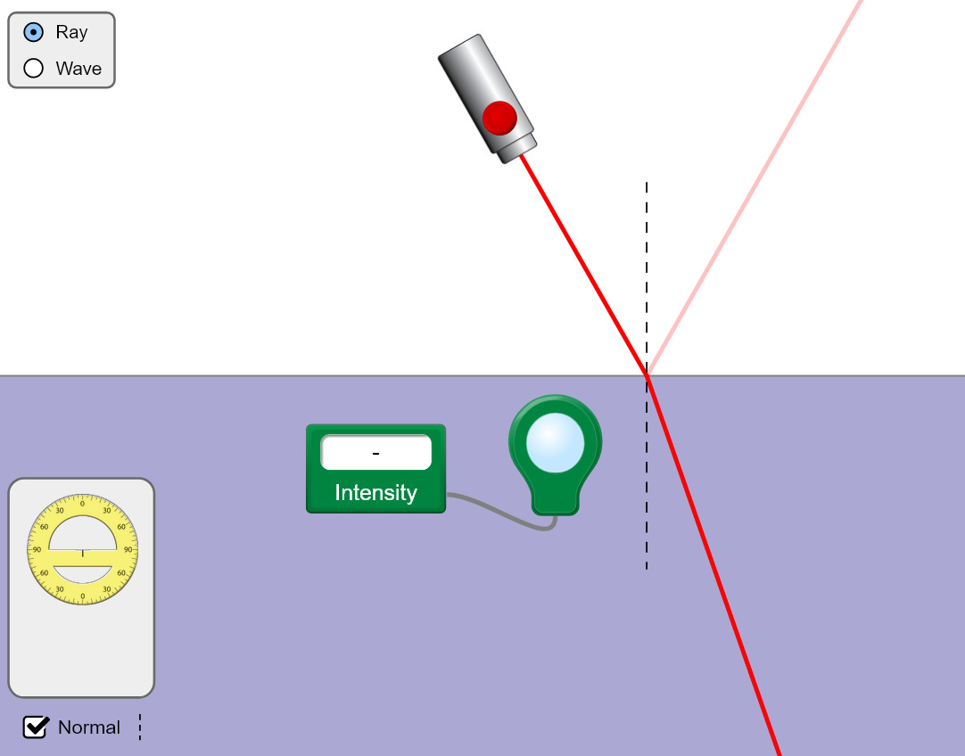

1. Take the **LENS** and drag it directly over the light coming from the laser **BEFORE** it hits the surface of the water. Notice you can measure the intensity of the light when the lens is placed over the beam. It should read ‘100.00%’
2. Move the lens out of the way and select the protractor tool from the toolbox. Set the laser to comes in at a **10o angle.**

Using the intensity tool, measure the Intensity of **Refracted** Light and Intensity of **Reflected** Light and record these in Table 2.

Repeat these steps for 5 more angles of incidence (over a large range) of your own choosing. Record the results in Table 2.

|  |  |  |
| --- | --- | --- |
|  | Intensity of **Refracted** Light (%) | Intensity of **Reflected** Light (%) |
| 10 |  |  |
|  |  |  |
|  |  |  |
|  |  |  |
|  |  |  |
|  |  |  |

*Table 2*

**Analysis:**

1. What two things does light do when encountering a change in medium?
2. As the angle of incidence increased, what happened to the intensity of refracted light?
3. As the angle of incidence increased, what happened to the intensity of reflected light?
4. As the angle of incidence increased, what happened to the total intensity of refracted + reflected light?

**Part 3: Refractive Index of a Mystery Material**

1. Reset the simulation to initial conditions.
2. Change the material of the first (incident) medium to ‘Mystery A’ and the second medium to Glass ).

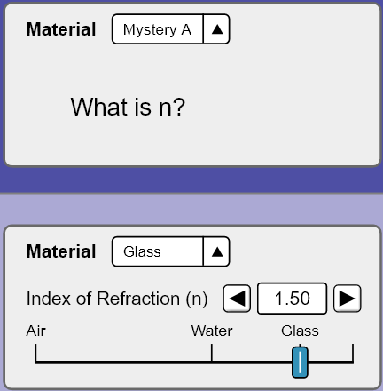

1. Change the incident angle of the laser and record six sets of results for in Table 3.

|  |  |  |  |  |
| --- | --- | --- | --- | --- |
|  |  |  |  |  |
|  |  |  |  |  |
|  |  |  |  |  |
|  |  |  |  |  |
|  |  |  |  |  |
|  |  |  |  |  |
|  |  |  |  |  |

*Table 3*

1. Calculate sin*θ1* and sin*θ2* for each trial and add them to Table 3. Then, using your known value of *n2*, calculate a value for *n1* for each trial and add these values to Table 3. Keep your results to 2 or 3 significant figures.

**Analysis:**

1. You were forced to use relatively small angles of incidence in this activity. Why would larger angles not have worked?
2. Show a sample calculation demonstrating how you determined *n2* for one

of your trials.

1. Calculate your average value of *n1*.
2. Using the table below, determine what the mystery material might be:

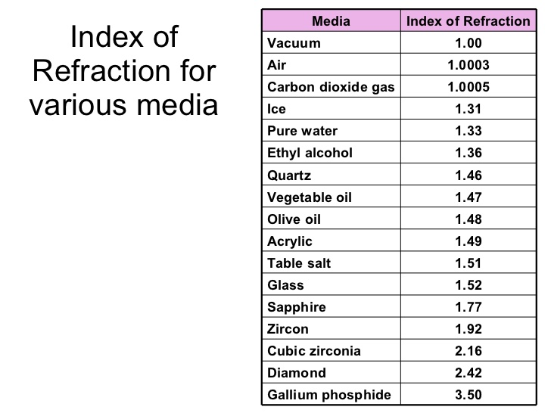

1. Find the percent error of your average value of *n1* using the identified

index of refraction as your accepted value.

**Further Analysis:**

1. Why does light bend, or refract, when it moves from one substance into

another?

1. Why must a beam of light be at an angle to bend when changing from one

medium to another?

# Extension Question

A laser begins underwater and is directed towards the surface. When the laser strikes the surface (above which there is air), it makes a 71° angle with the normal. What happens when you try to use Snell’s Law to predict the angle the laser makes when it passes into the air? Explain what physically happens to the laser beam.