Instructor:

Mrs. Amanda Cleveland

Ph. # 606-4800, ext. 3640

Email: acleveland@lvjusd.org

Office Hours:

Monday - Wednesday @Lunch

**CHEMISTRY A & B**

**Syllabus**

**Granada High School**

**COURSE OBJECTIVES**:

Chemistry is a college preparatory course that is intended to acquaint students with the major concepts of Chemistry. This is a lab-oriented course and deals with many quantitative measurements. This course requires the use of mathematics to solve problems on a regular basis. **A fundamental understanding of algebra and the ability to apply basic algebraic concepts is necessary.** The course will also allow students to use their critical thinking skills and investigate the science of chemistry through inquiry. In addition to “recipe” labs to learn concepts, students will be developing their own experiments to investigate.

**ATTENDANCE:**

Each student is expected to attend class daily.

Tardiness - Students will be marked tardy if they are not in their seats when the tardy bell rings.

Excused Absences will be allowed as many days as they were absent to make up any missed work. If a student misses a lab, they will be provided data from the lab to complete the assignment. Missing more than 2 labs will affect the ability to pass the course.

Unexcused Absences - Any work missed during an unexcused absence will be given a zero.

**LABORATORY:**

Safety - Students are required to wear the provided safety goggles and aprons for all labs.

Equipment - Students will be charged for any items lost, or broken through carelessness or neglect.

Lab Notebook - Each student will benefit from a 1 inch binder with 7-8 Tabs

*Lab reports are usually due* ***two classroom days*** *after completion of data collection.*

**Grade Breakdown:**

[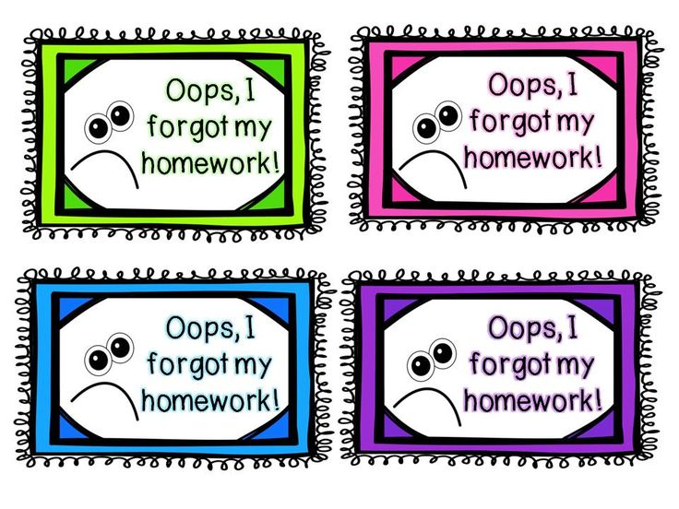](http://images.google.com/url?sa=i&rct=j&q=late+homework+pass&source=images&cd=&ved=0CAcQjRw&url=https://www.pinterest.com/pin/317855686174287612/&ei=l8kAVc7YMIfvoAS984HADg&bvm=bv.87920726,d.cGU&psig=AFQjCNFipUPAopaJnePRpiPyYkcC4zFDWw&ust=1426201322103309)

Students are encouraged to be proactive about assignments but **LATE WORK HAPPENS:** Students will be given four (4) “late work passes” that can be used on any assignments besides quizzes and tests. Passes are valid one week after original deadline.

**SUPPLEMENTAL CREDIT**

Students have the option to research a current event in chemistry OR check out the *Culinary Reactions* book.

A presentation to the class must be completed based on the guidelines provided. These guidelines can be found on the Student Matter wall in the classroom. All presentations must be turned in no later than the LAST THURSDAY before finals.

No extra credit assignments will be awarded to those who have missing assignments.

**I have read and understand the preceding general background and orientation.** (DO NOT DETACH!) This will be returned and is to be placed in the class notebook.

**___________________________ ____________________________ __________**

**Student’s Name (please print) Student’s Signature Date**

**___________________________ ____________________________ __________**

**Parent Name (please print) Parent’s Signature Date**