Ag Chem Stoichiometry Guided Notes

Balancing Chemical Equations - Coefficients

CH₄ + 2 O₂ → CO₂ + 2 H₂O

Reactants Products

________ _________

________ _________

________ _________

Meaning of Chemical Formula

Chemical Symbol Meaning Composition

H₂O 1 molecule of water two H atoms and one O atom

2 H₂O 2 molecules of water four H atoms and two O atoms

H₂O₂ 1 molecule of Hydrogen peroxide two H atoms and two O atoms

Unbalanced and Balanced Equations

H₂ + Cl₂ → HCl (unbalanced H₂ + Cl₂ → _____HCl (balanced)

Reactants Products Reactants Products

H H

Cl Cl

The Mole Concept

Avogadro’s Number = 6.022 X 10²³

Counting Atoms

Chemistry is a ___________________________________ - we need a counting unit.

The _______________________

1 mole is the _____________________________________________________ that contains as many particles as there are in ____________________________________.

The Mole is developed

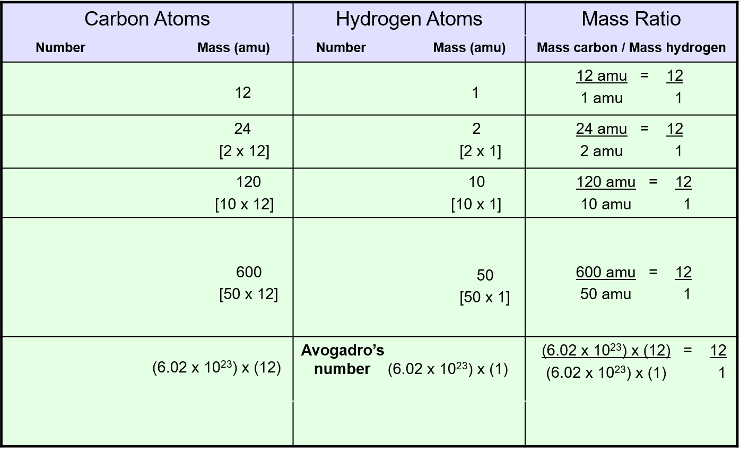

**number**

A Particles in a mole

Amadeo Avogadro

1 mole = 602213673600000000000000 or 6.022 X 10²³

This is Avogadro’s number of particles in a mole of any substance.

Careers in Chemistry – Philosopher

Q: How much is a mole?

1. A mole is a quantity used by chemists to count atoms and molecules. A mole of something is equal to 6.022 X 10²³

Q: Can you give me an example to put that number in perspective?

A: A computer that can count ____________________________________ atoms per second would take __________________________ years to count 1 mole of a substance.

Counting to 1 Mole

Is that right? A computer counting __________________________ every second would need to count for ______________________ just to count just a single mole.

Let’s look at the mathematics.

Therefore 1 year has ____________________________________ seconds or _________________________.

A computer counting _____________________________atoms every second could count ________________ atoms every year.

Finally ________________________ divided by _________________________________atoms every year equals ________________________________________ or approximately 2 billion years!

Avogadro’s number

1. A _________________ of any substance contains as many elementary units (atoms and molecules) as the number of atoms in 12g of the isotope ________________________
2. This number is called __________________________________________________________________

Particles/mol

1. The mass of one _________________ of a substance is called __________________________________ symbolized by MM
2. Units of MM are __________________
3. Examples
   1. H₂ ______________________ __________________________
   2. He ______________________ __________________________
   3. N₂ ______________________ __________________________
   4. O₂ ______________________ __________________________
   5. CO₂ ______________________ __________________________

Molar Mass

Molecular Weight and Molar Mass

Molecular weight _______________________________________________________________________________

______________________________________________________________________________________________

Ex: NaCl has a molecular weight of ____________________ this is composed of a single molecule of NaCl

Molar Mass ___________________________________________________________________________________

Ex: NaCl has a molar mass of _______________________________ this is composed of a 6.02 X 10²³ molecules

Of NaCl

The Molar Mass and # of Particles in One Mole Quantities

Substance Molar Mass # of Particles in One Mole

1

2

3

4

5

6

7

Combustion Reaction

Hydrocarbon + O₂ → CO₂ + H₂O

Synthesis Reactions

A + B → AB or AB + C → ABC

Decomposition Reactions

AB → A + B

Single Replacement Reactions

A + BC → B + AC

Double Replacement

AB + CD → CB + AD

Mole Island Diagram

1 mole = ________________________________

1 mol = ________________________________

1 mol = ________________________________

Stoichiometry Island Diagram

Mole Calculations

Proportional Relationships

I have 5 eggs. How many cookies can I make?

Proportional Relationships

Stoichiometry

* __________________________________________________________________________________
* __________________________________________________________________________________

Mole Ratio

* __________________________________________________________________________________

_______ Mg + O₂ → ________MgO

Stoichiometry Steps

1. ______________________________________________________________
2. ______________________________________________________________
3. ______________________________________________________________

Mole ratio – moles – moles

Molar volume – Moles – liters gas

1. _______________________________________________________________

Molar Volume at STP

1 mol of a gas = ___________________________________________________________

STP = Standard Temperature & Pressure

Molar Volume at STP

Stoichiometry Problems

How many moles of KClO₃ must decompose in order to produce 9 moles of oxygen gas?

_____ KClO₃ → _____KCl + _____O₂

? Mol 9 mol

How many grams of KClO₃ are required to produce 9.00 L of O₂ at STP?

______KClO₃ → _______KCl + _______O₂

?g 9.00 L