Name _________________________________________

***Smart Cart Lab: 1-D Kinematics* (Distance Learning Version)**

(In this distance-learning version of this activity, all needed data can obtained from screenshots have been provided.)

In this lab, we’ll use PASCO Smart Carts and SPARKvue software to analyse the kinematics of a car rolling down a ramp.

Procedure:

1. Obtain a 1-m long track. Prop one end up with a textbook.
2. Obtain a single Smart Cart. Turn it on, and make sure you see a blinking red light. This means it is blue tooth ready. Remove the magnetic “bumper” from the front of your Smart Cart.
3. Obtain a PC laptop, insert a Bluetooth adapter into a USB port, begin running SPARKvue, and connect your Smart Cart to SPARKvue.
4. Build an experiment with 4 pages. On the first page, have a data table with columns for time, position, velocity, and acceleration. (You can add columns to your data table by clicking on the icon at the bottom of the page.) On the 2nd page have a graph of position vs. time. On the 3rd page have a graph of velocity vs. time. On the 4th page have a graph of acceleration vs. time.
5. Place your Smart Cart at the top of the ramp. Click on the button to start taking data, then release the car. After the car has hit the barrier at the bottom of the ramp, click the button to stop taking data.

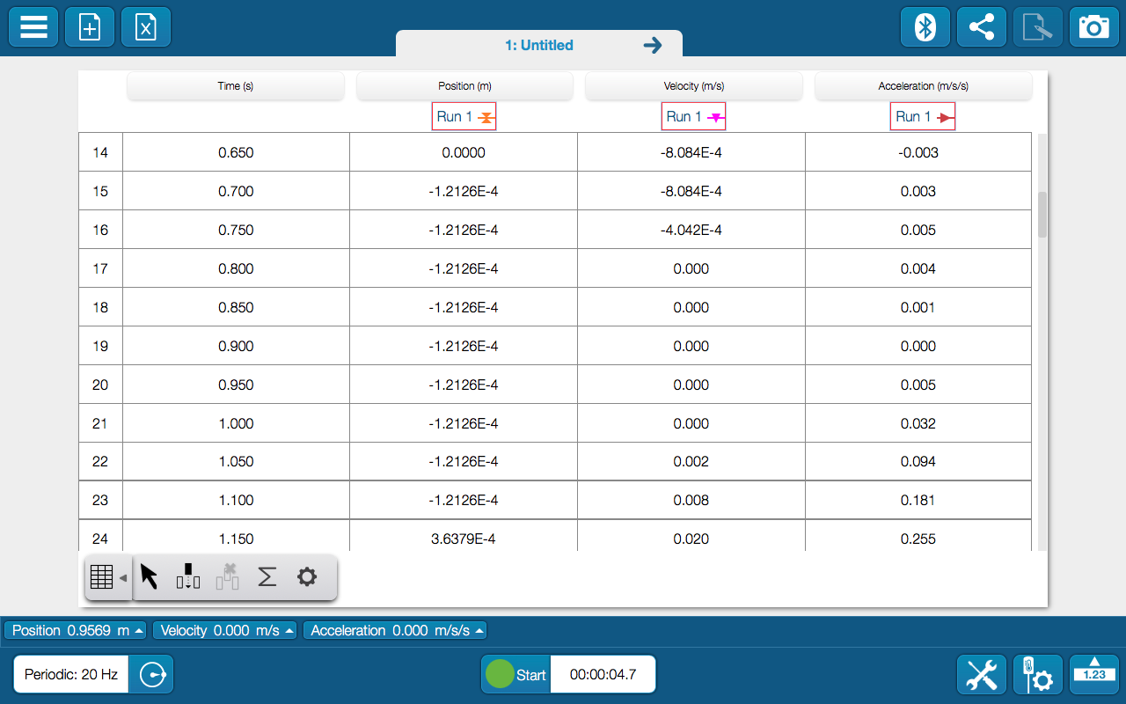

1. Determine the time of the exact moment when you released the car: *tbegin* = ________.

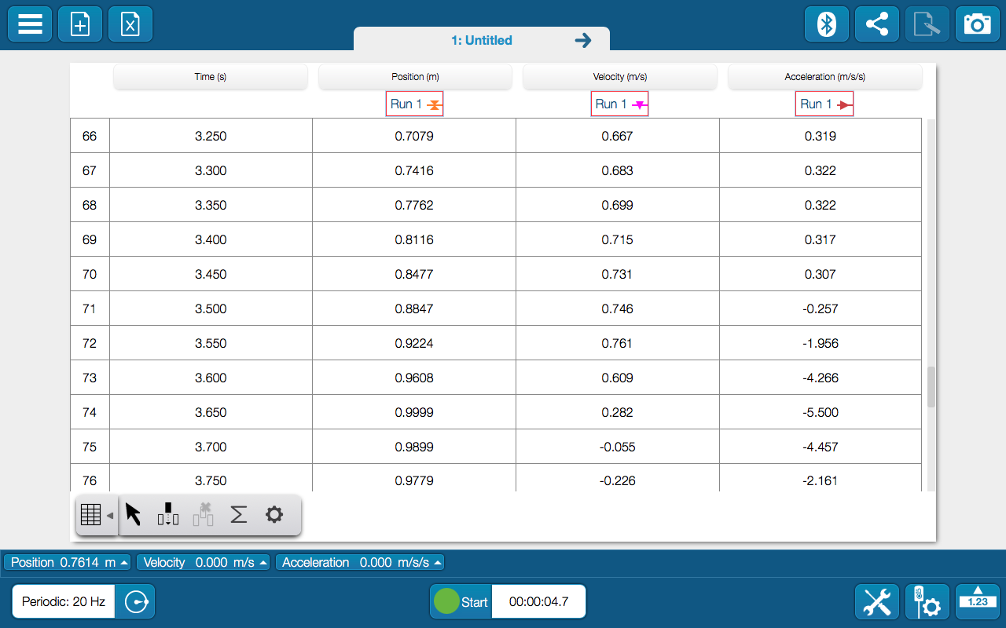

1. Use acceleration data to determine the time of the exact moment when the car hit the barrier: *tend* = ________.
2. Fill out the following, using the data table on the first page of your experiment build:

**Table 1**

|  |  |  |  |  |
| --- | --- | --- | --- | --- |
|  | Time (s) | Position (m) | Velocity (m/s) | Acceleration |
| Car is released |  |  |  |  |
| Car hits barrier |  |  |  |  |

1. Use your velocity and time data above to calculate the average acceleration of the cart while it was rolling down the ramp. Show all work below:

*aavg* = ________________

1. Use your velocity and position data above to calculate the average acceleration of the cart while it was rolling down the ramp. Show all work below:

*aavg* = ________________

1. Are your results from #9 and #10 consistent? Explain.
2. On page 2 of your experiment build you should have a graph of position vs. time. Locate the moment the car was released, and annotate that point. Be sure to drag your text box to the side so it is not covering up your data. Then repeat for the moment the car hit the barrier.
3. Highlight the portion of your graph between when the car is released, and when it hits the barrier. Do a quadratic fit to the data. Then save this page to your journal.

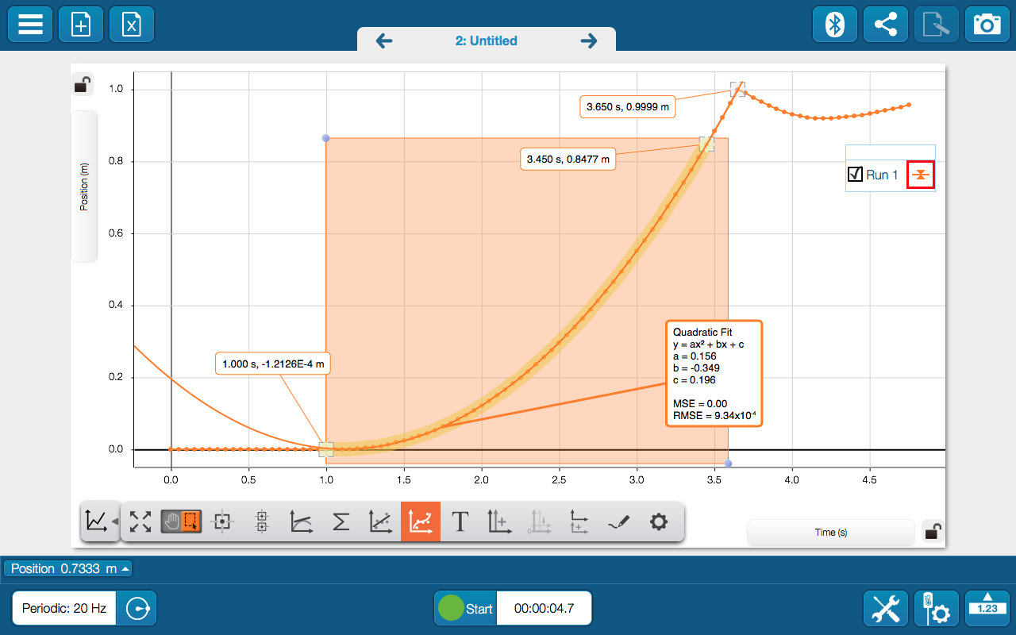

1. What is the equation of the quadratic fit to your position vs. time data?
2. Based on your answer to #14, what was the average acceleration of the cart during its descent? Explain/show work below:

*aavg* = ________________

1. On page 3 of your experiment build you should have a graph of velocity vs. time. Locate the moment the car was released, and annotate that point. Be sure to drag your text box to the side so it is not covering up your data. Then repeat for the moment the car hit the barrier.
2. Highlight the portion of your graph between when the car is released, and when it hits the barrier. Do a linear fit to the data. Then save this page to your journal.

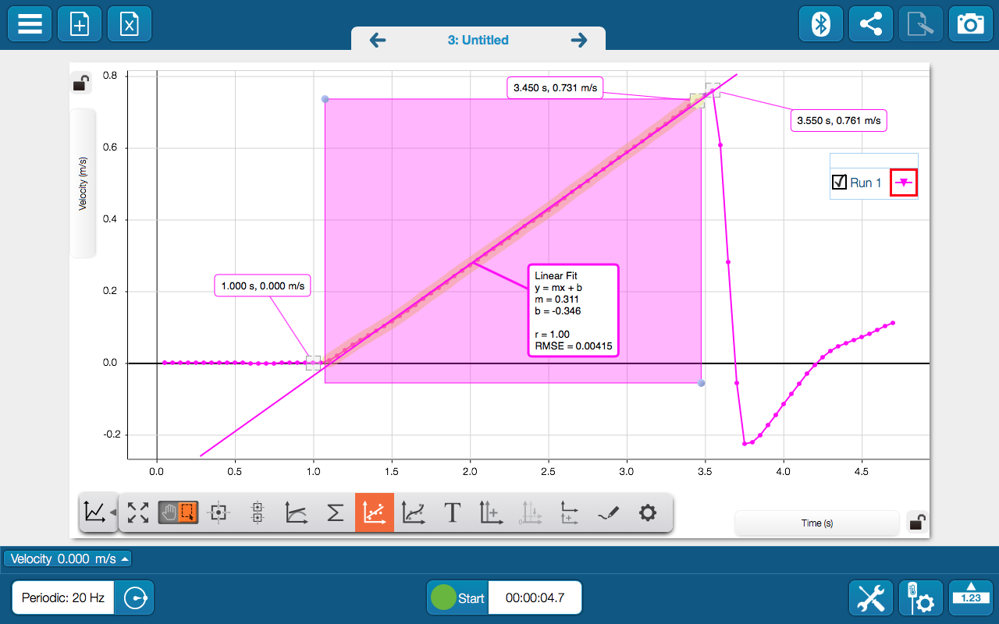

1. What is the equation of the linear fit to your velocity vs. time data?
2. Based on your answer to #18, what was the average acceleration of the cart during its descent? Explain/show work below:

*aavg* = ________________

1. On page 4 of your experiment build you should have a graph of acceleration vs. time. Locate the moment the car was released, and annotate that point. Be sure to drag your text box to the side so it is not covering up your data. Then repeat for the moment the car hit the barrier.
2. Highlight the portion of your graph between when the car is released, and when it hits the barrier. Determine the mean value of acceleration during this interval. Then save this page to your journal.

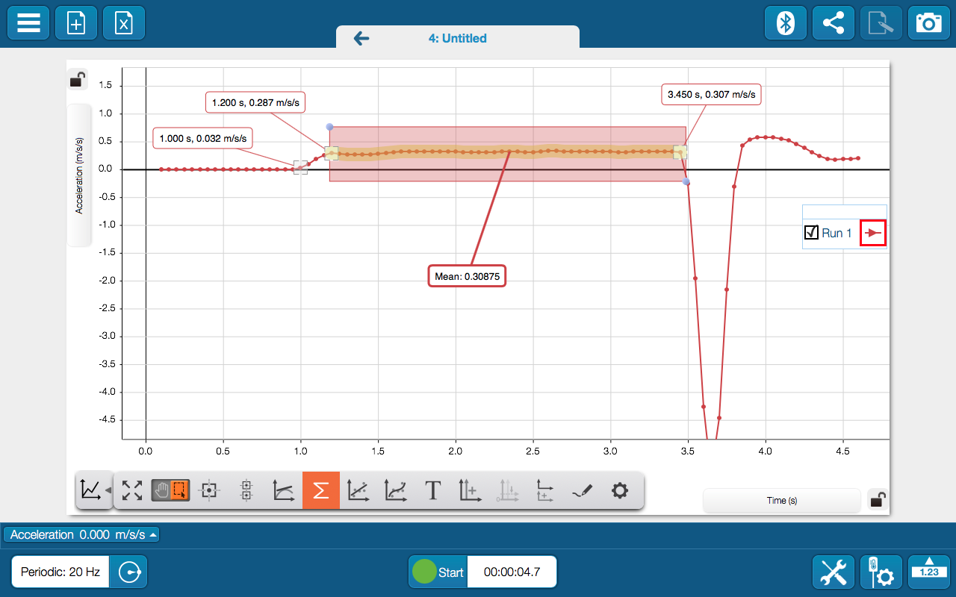

1. What was the mean value of acceleration during the highlighted interval?

*aavg* = ________________

1. Would you say your overall results were consistent? Explain? (Include a discussion of any possible sources of error.)