**Diffraction Lab: Recreating Young’s Double-Slit Experiment**

The purpose of this lab is to use an online diffraction simulation to recreate Thomas Young’s double-slit experiment measuring the wavelength of light.

# Background:

According to *Huygen’s Principle* each point on the wavefront (crest) of a wave can be considered to be a source of a new wave, expanding out in all directions. Thus, when waves pass through a narrow opening (slit), waves expand in concentric circles on the other side of the slit. If you have more than one slit, the circularly expanding waves with interfere with one another. Where the two waves are in phase (crest-meets-crest, trough-meets-trough) the two waves *constructively interfere* and the wave intensity is increased. Where the two waves are out of phase (crest-meets-trough) the two waves *destructively interfere* and cancel each other out. This is why, when light is passed through two (or more) slits, a pattern of light and dark spots appears – the light spots correspond to locations where the waves passing through the slits constructively interfere; the dark spots correspond to destructive interference.

Figure 1

A wave whose wave fronts are parallel to each other passes through two slits. Circularly expanding wave fronts emerge on the far side of the slits. Notice that you can draw straight lines connecting locations where crest-meets-crest. Constructive interference thus occurs along the three arrows shown between the slits and the screen. These arrows indicate where bright spots will appear on the screen.

Consider the situation below:

Light with wavelength λ passes through slits distance *d* apart. Distance *L* behind the slits is a screen. The central bright spot appears at point *P0* . The next bright spot appears distance *x* away at point P1.

Figure 2:

P1

x

S1

d

P0

S2

L

Since the distance from *S1* to *Po* is equal to the distance from *S2* to *Po*, waves from both slits arrive at *Po* in phase, so a bright spot appears. Similarly, if the distance from *S2* to *P1* is exactly one wavelength longer than the distance from *S1* to *P1*, then waves from both slits will also arrive at *P1* in phase, and a bright spot will appear there as well.

Using geometry, one can show that the following relationship must be true:

λ = xd/L

This formula also holds if you have *many* slits. By passing light through tiny slits, and *carefully* measuring *L*, *x*, and *d*, Young was the first person to calculate the wavelength of visible light.

**Procedure:**

1. We will be using the Wave Interference simulation on the University of Colorado Boulder’s PhET web page.

Go to the web site <https://phet.colorado.edu/en/simulation/wave-interference>

and click the “play” icon. You should see a screen that looks like this:

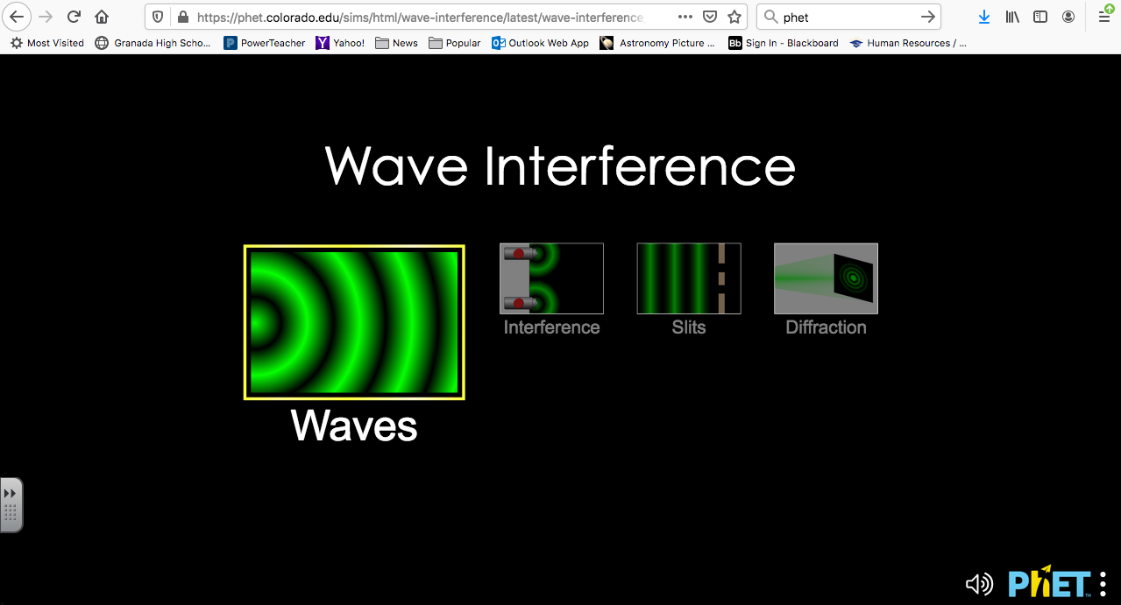

1. Click on the “Slits” option.
2. This simulation let’s you generate water, sound, or light waves, as indicated by the faucet, speaker, and laser pointer icons on the right side of the screen. We will be simulating light waves, so click on the laser pointer icon.
3. The default option is to have one slit. Click and change the option to “Two Slits”. Your screen should now look like this:

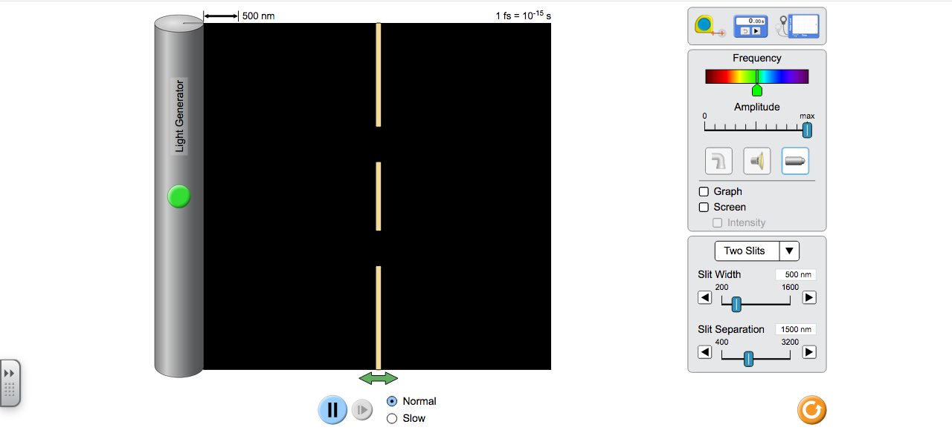

**Part I: Investigating Double-Slit Diffraction**

1. Click “Screen” on the right to activity a screen to project upon. Then click the green button the light generator. You should now see something like this:

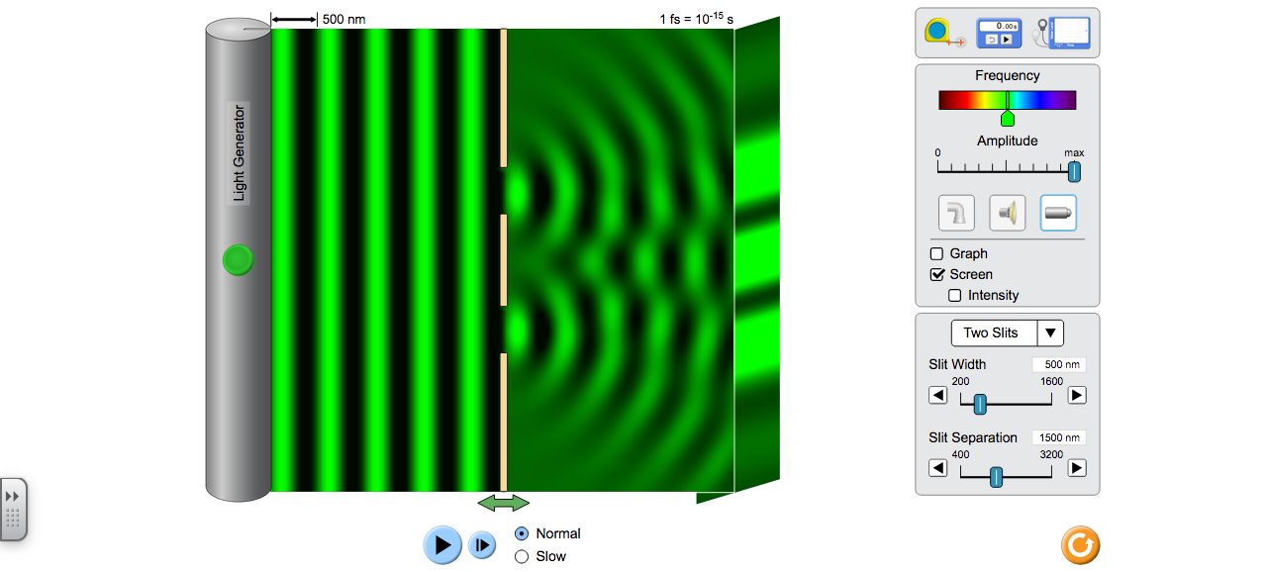

1. Play with adjusting the slit width and slit separation in order to answer the following analysis questions:

Analysis Questions:

1. What effect does narrowing the slits have on the intensity and thickness of the central and first order bright spots?
2. What effect does changing the slit separation have on the spacing of the bright spots?

**Part II: Recreating Young’s Experiment**

1. Return the slit width to 500 nm and slit separation to 1500 nm. Record your slit separation *d* in Table 1.
2. Press the green button on the light generator and generate an interference pattern on the screen. (Again, you should see something like what you see at the top of this page.)
3. Pull the measuring tape tool out of the box in the upper right and use it to measure *L*, the distance between the slits and the screen. Then measure *x* the distance from the center of the central bright spot to the center of one of the 1st order bright spots. Record these values in Table 1. (Be sure to include units!!!)
4. Calculate the wavelength of the green light λ using the diffraction formula derived in the Background section. Record this value in Table 1.
5. Pause the simulation and use the measuring tape tool to measure the wavelength directly. Record this value in Table 1.
6. Calculate the %-error between your calculated and measured values, and record this value in Table 1.
7. Adjust the frequency of light so that it is now in the red part of the spectrum and repeat steps B-F.
8. Adjust the frequency of light so that it is now in the violet part of the spectrum and repeat steps B-F.

|  |  |  |  |  |  |  |
| --- | --- | --- | --- | --- | --- | --- |
| **Color of Light** | **Slit Separation *d*** | **Distance from Slits to Screen *L*** | **Distance from Central to 1st Order Bright Spot**  ***x*** | **Wavelength λ (calculated)** | **Wavelength λ (measured)** | **%-Error** |
| Green |  |  |  |  |  |  |
| Red |  |  |  |  |  |  |
| Violet |  |  |  |  |  |  |

**Analysis:**

1. In your lab report, be sure to show sample calculations for your trial with green light.
2. What happened to the spacing of the bright spots when you increased the wavelength of the light being diffracted?
3. Explain why your answer to #4 occurred.

**Extension Questions:**

1. Annika created an interference experiment in order to measure the thickness of her hair. She taped one of her hairs to a microscope slide, stood the slide upward with some modeling clay, and shined a 632-nm red laser beam into the hair. The space on either side of the hair acted as a double-slit. She projected the resulting interference pattern onto a screen 10.2 meters from her hair. If the center of the first-order bright spot was 3.3 cm from the center of the central bright spot, how thick is Annika’s hair?
2. CD’s, like vinyl records, store information in grooves. Unlike vinyl records, these grooves are too small to be seen with the human eye. Raffi decided to design a diffraction experiment in order to measure the thickness of these tiny grooves. Raffi shined a 632-nm red laser onto a CD. Since there are many tiny grooves, the grooves acted like a diffraction grating. When Raffi projected the reflection of the laser beam onto a screen 33.0 cm away from the CD, a 1st order bright spot appeared 12.8 cm away from a central bright spot. How thick were the grooves on Raffi’s CD?
3. If the grooves on a CD begin at the outer diameter (radius = 5.0 cm) and end at the inner diameter (radius 2.0 cm), how many grooves are on a CD?