Name: ______________________________________

**Lab: Predicting Radioactive Decay is Dicey**

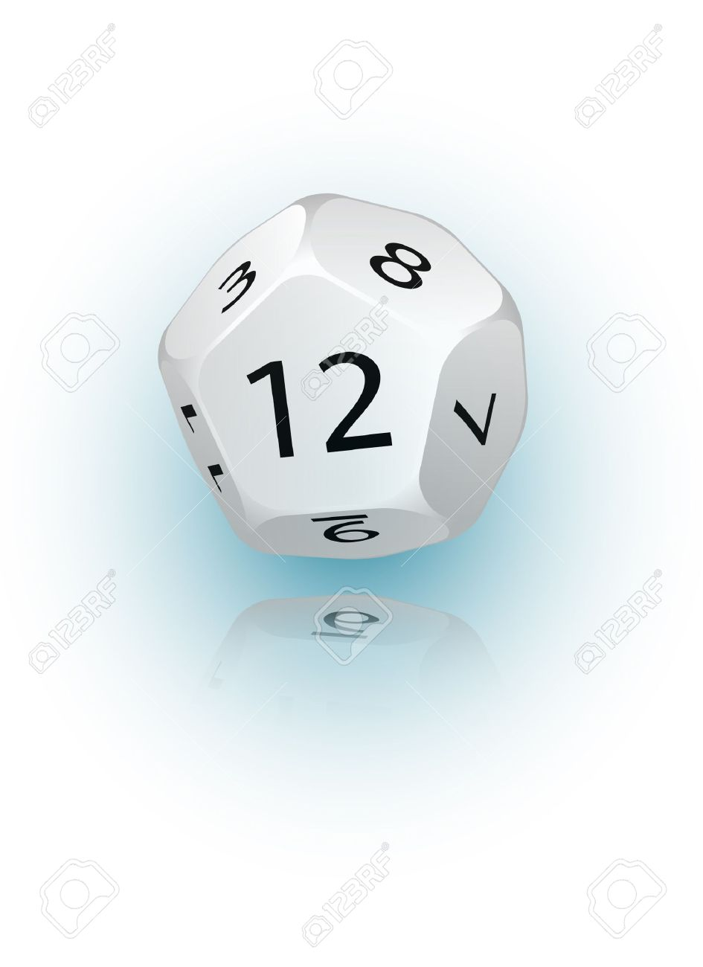

Today we’re going to simulate radioactive decay using 12-sided dice to represent unstable nuclei. We will begin with 100 “diceium atoms”. Then, once a minute, we will roll the dice. Any die that comes up “one” will be considered decayed, and removed from the amount we have left. After continuing this process for about half an hour, we will graph our data, and use the graph to determine the half-life of “diceium”. Finally, we will compare this experimentally determined half-life with what we would predict theoretically, given that the likelihood of any given “diceium” atom decaying in a given minute is 1/12.

Let’s begin!

|  |  |  |  |  |  |  |  |
| --- | --- | --- | --- | --- | --- | --- | --- |
| Time elapsed (min) | Undecayed diceium nuclei | Time elapsed (min) | Undecayed diceium nuclei | Time elapsed (min) | Undecayed diceium nuclei | Time elapsed (min) | Undecayed diceium nuclei |
| 0 | 100 | 11 |  | 22 |  | 33 |  |
| 1 |  | 12 |  | 23 |  | 34 |  |
| 2 |  | 13 |  | 24 |  | 35 |  |
| 3 |  | 14 |  | 25 |  | 36 |  |
| 4 |  | 15 |  | 26 |  | 37 |  |
| 5 |  | 16 |  | 27 |  | 38 |  |
| 6 |  | 17 |  | 28 |  | 39 |  |
| 7 |  | 18 |  | 29 |  | 40 |  |
| 8 |  | 19 |  | 30 |  | 41 |  |
| 9 |  | 20 |  | 31 |  | 42 |  |
| 10 |  | 21 |  | 32 |  | 43 |  |

Now, graph this data on the next page! (Be sure to title the graph, and label the axes!)



1. Use your graph to obtain 3 different values for half-life:
2. What is the average of your results from #1?
3. Now let’s compare experimentally determined results with theory. We know that the probability of a given “diceium” atom decaying in one minute is 1/12. Given this information, write a formula for the amount *A* of diceium left after *t* minutes have elapsed. The equation should be of the form *A*(*t*) = *A0(a)t/T.*
4. Use your equation in #3 to calculate the theoretical half-life for “diceium”. Show all work below.
5. What is the percent difference between your experimentally and theoretically determined half-lives?